EXPERIMENT-4

AIM : To perform relational set operations(i.e UNION

UNIONALL,INTERSECT,MINUS,CROSS JOIN,NATURALJOIN.)

Creating tables :

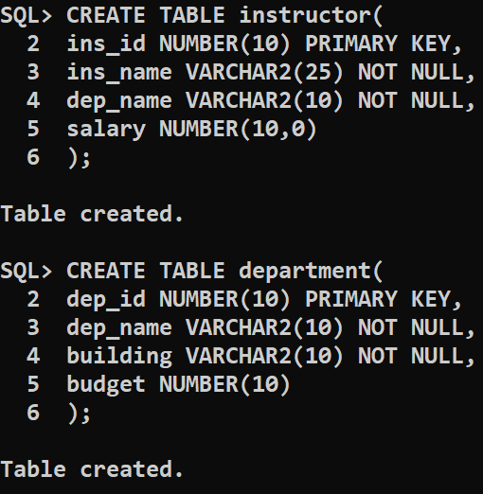

Inserting values into **INSTRUCTOR** table :

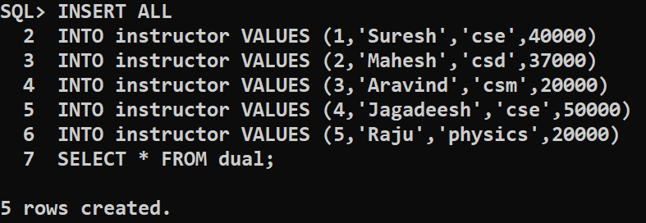

Inserting values into **Department** table :

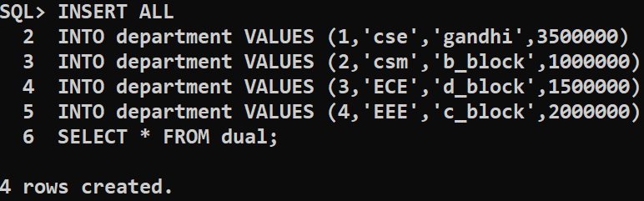

Union operation :

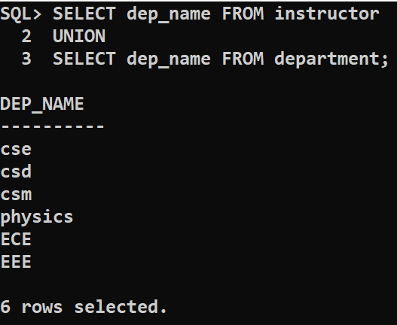

Union all operation :

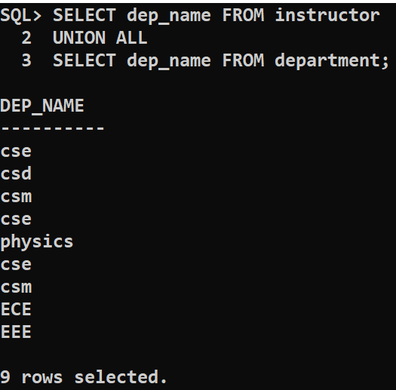

Intersect operation :

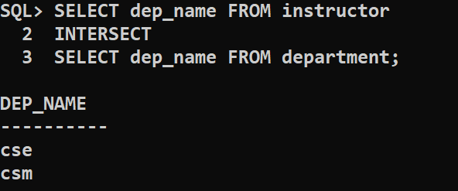

Minus operation :

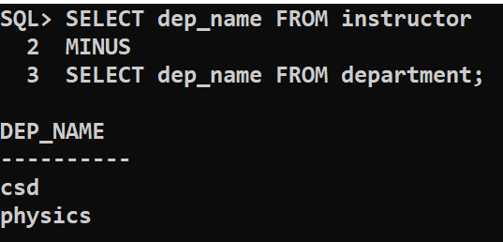

Conclusion : The sql queries to perform relational set operations is successfully executed.